Vision Statement from our NH Conference, United Church of Christ
OUR VISION is a world that seeks compassion, justice and peace for all people, a faith that celebrates the Holy Spirit as the source of joy, growth and healing, and a church that offers to all a dwelling place with God and for God.

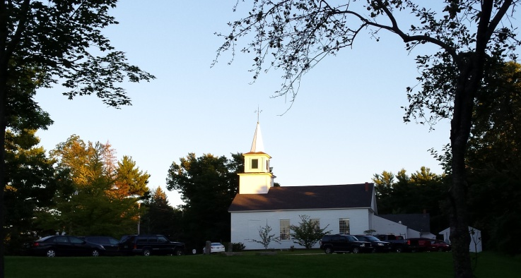
Mason Congregational Church Mission
A welcoming Christian family; worshipping, growing, and serving all in Christ’s love.
From the desk of Pastor Veronica…

"All who believed were together and had all things in common;" (Acts 2:44)

I have only been on the scene as your Pastor here at Mason Congregational Church UCC for a bit over one month. But, the spirit of Christian fellowship I have seen, even in unguarded and "unofficial” moments gives me hope that you are really who you try to be: sincere Christians.
As we end the summer and begin to pick up steam for autumn with the yard sale and Sunday School and Confirmation and a wedding and whatever else the Lord gives us to do, I look forward to learning who each of you are so we can enjoy this journey of faith together.
It is good to be back in New Hampshire. And it is good to know the values I remember from living here years ago are still alive and well.
Remember, I am in the church office on Monday, Wednesday and Thursday mornings.
The church number is 603-878-1684. My home phone number is 603-213-6368.
Stop in for a chat so we can get to know each other.
Don't forget, we can see each other on a regular basis when you come to SUNDAY MORNING WORSHIP AT 10:00 AM. Pastor Veronica
Save the Date:

- September 13 Old Home Day, and Mason Church Yard Sale The yard sale will start at 11 am, after Worship Service. Clean your closets, look around for unused items, this is your opportunity to “Free-Cycle” your extra belongings. Please No books, No baby furniture, no electronics. You can drop off items at the church carriage shed, or call Betty Goen 878-2374 or Cindy Tibbetts 878-3904 to arrange for pick-up.

- No Community Supper in September due to the Chicken BBQ Sept 13. Buy your chicken BBQ tickets by calling Karin at 878-2675.
- Be sure to attend Old Home Day, Sunday Sept 13. There are many special events, including activities for children, a fun run, booths of local crafts and information, and a special treat--a dunk tank sponsored by the Mason Citizens Against the Pipeline.
- Community Supper October 8th This is our traditional Harvest Supper with all the trimmings—Roast turkey, stuffing and gravy, mashed potatoes, winter squash, and vegetables. Crowned by the famous apple dessert.
- Mason Church Christian Education will begin in September 20. This is a chance for children to learn the stories that have guided our culture for the past 2000 years. We always need helping hands, so come teach, learn, and enjoy our children. Sign up on the 20th or at Old Home Day at the Mason Church Table, where you can have face painting too!
- Coffee House on September 19 at 7pm Tom Keating is our feature performer, and of course, we will have some other musicians treat us to their talents as well. Don’t miss live music in Mason.
- Church Garden The Church garden is like the loaves and fishes… it has been very prolific, thanks to loving planting, care, and picking. Betty has delivered much of it to St Vincent DePaul, and some is shared here in town.
- Updating Church Directory: Send corrections or additions to miscott39@gmail.com
Yarn into Prayer Shawls! Join the knitters of Mason Church in the prayerful knitting. If you know someone who needs the warmth and prayers of a shawl please contact: Susan Suokko at Usercat2@comcast.net or 941-920-0270 or call Linda Lannin.
Adult Study Groups We will pick up our Adult Study groups in the fall under the direction of the pastor , the deacons, and the education committee.
Are you listening? Please reach out, remember, and care about friends, neighbors, and our environment…
- Keep Informed about the Pipeline-through-Mason issues by going to meetings every Monday evening. And visit these websites www.nhpipelineawareness.org and http://masonnh.us/pipeline-project-information/ for information and maps. Write a letter to the Federal Energy Regulatory Commission(FERC), and go to
www.Mason-NH.org/FERC_COMMENTS.pdf to read some of the letters that have been sent in.
- Arthur Rafter is always in our thoughts. Write or call him, as he misses us, maybe as much as we miss him. Arthur, c/o Jane and Gary Goodhart, 19 Meadow Lane, Pleasant Valley, NY 12560. Phone # 345-635-1405
- Keep Cindy Tibbetts in your prayers. Sooner or later the medical profession will figure out what will help her most. Give her a call at 809-2036 or 878-3904 to see if she needs a ride, some company, etc.
- Marcia Osborn Remember Marcia? She was an active and beloved member of our church. She moved to Peterborough to avoid winter driving and be closer to family. And now her family has moved to Charlotte, NC. Her new address is Waltonwood Apt 316, 11945 Providence Rd, Charlotte, NC 28277 Drop her a line!
- Linda and John Lannin have moved to Mont Vernon! We will welcome the family who purchased their house, and hope that Linda and John will continue to join us on many occasions! Their new address is 13 Westgate Rd, Mont Vernon, NH 03057 Phone # 554-8914
- St Vincent DePaul—Food Pantry asks that if you are able, the Food Bank hopes you will buy one extra item each week to share with those in need. There is a large tote in the entryway of Fellowship Hall which will gratefully receive your offering.
- Do you know someone who needs spiritual support or other support, of the pastor and deacons? Please call, your church family may be able to help. Leave a confidential message for the pastor at 603-878-1684 or on her personal phone at 213-6368.
- Any news items, comments, or things you would like to share: contact Michelle at 878-1680 or miscott39@gmail.com

